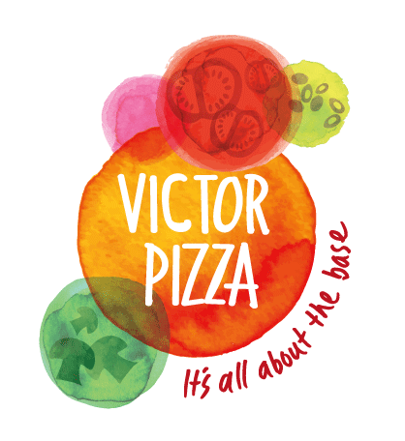
The Victor Pizza Company Limited

90-94 Glentanar Rd
Balmore Industrial Estate
Glasgow
G22 7XA
0141 881 5837
Date 05/03/2020

RE: COVID-19 (CORONAVIRUS)

In relation to the corona virus (COVID-19) that originated in Wuhan, Hubei Province, China, The Victor Pizza Company Ltd have assessed the possible risks and have adopted necessary mitigation measures to ensure ongoing supply and manufacturing capacity.

The World Health Organisation has declared that the outbreak of Covid-19, commonly known as Coronavirus, constitutes a public health emergency of international concern (30th January 2020).
As part of our standard business proceedings, The Victor Pizza Company constantly monitors our supply chain for any adverse factors which could potentially cause disruption for our customers and employees. Despite the scale of the current outbreak, the potential risk presented by the Coronavirus falls within the scope of our existing supply chain management procedures and Victor Pizza can confirm that we have adequate procedures and policies in place to pre-empt and manage such situations.
We have imposed restrictions on access to our manufacturing site in Possil for people ‘at risk’ areas and are currently monitoring all travel requests for employee holidays.
Moreover, the management at Victor Pizza Co have taken the necessary steps to ensure proper policies and procedures have been met, regarding both people and the material mitigation methods employed by our suppliers.
Momentarily we do not foresee any issues with regard to raw material supply, as our suppliers have confirmed they do not expect any impact on supply at this time.
In regard to the unpredictability of the virus, we plan to closely monitor and update our employees and customers to ensure correct steps are in place in order to ensure continuity of production and product delivery.
We remain committed to providing the superior service and support that our customers have come to expect of our company throughout this situation.

